Columns in Issue Navigator
The Issue Navigator Columns page (Illustration 2: Issue Navigator Columns) is used to edit the columns that are displayed when a search is carried out, on the Issue Navigator page. The same set of columns are used when performing a bulk operation.
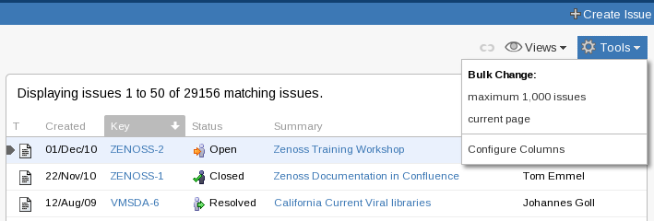
Illustration 1: Issue Navigator: Tools drop-down
To get to the Issue Navigator Columns page
- Select the 'Tools' drop-down menu, situated on the right above the list of issues. (Illustration 1: Issue Navigator: Tools drop-down)
- Select 'Configure Columns', if this is a new search (Illustration 1)
or 'Edit filter's Column Order', if this is a saved filter (Illustration 3: Alternate Tools drop-downs) depending on the form of the menu.
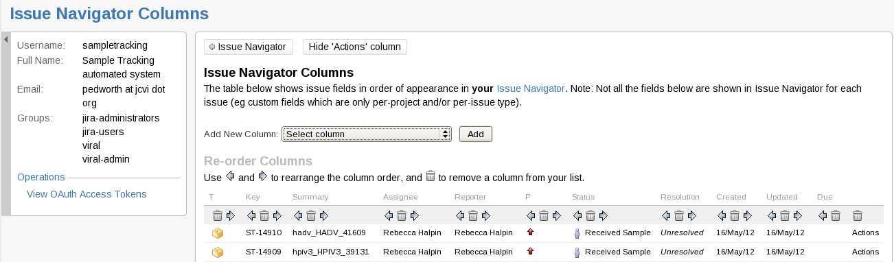
Illustration 2: Issue Navigator Columns
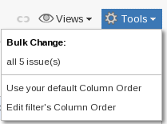
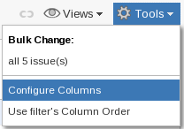
Illustration 3: Alternate Tools drop-downs
The Issue Navigator Columns page contains buttons and links to add, remove and arrange columns containing any of the fields, including custom fields. The side-bar contains information about the user and is completely unrelated to the rest of the Issue Navigator Columns page.
Each column has up to three icons at its top:
Swap the column with the column to its left or right
Remove the column. If a column is accidentally removed it can be re-added via the 'Add new
Column' drop-down.
Adding/re-adding fields is controlled outside the table. (Illustration 4: Add New Column drop-down and button). Only one field can be added at a time, the field is selected using the 'Select Column' drop-down menu and then confirmed by clicking the 'Add' button.
Illustration 4: Add New Column drop-down and button
The menu contains all of the fields in JIRA and so can be quite long. The fields are in alphabetical order and so knowing the exact name of the field is helpful. The name used for a custom field can be found on the Issue Summary page. On the Issue Summary page the custom fields are in two areas; below the standard fields on the left in the 'Details' section and on the right in the 'Dates' section.
For example in Illustration 5: Issue summary view the 'Details' section contains three custom fields; Blinded Number, Database and Collection Code. The 'Dates' section contains only one custom field; Sample Arrival Date. The column name in the 'Add New Column' drop-down will exactly match these names.
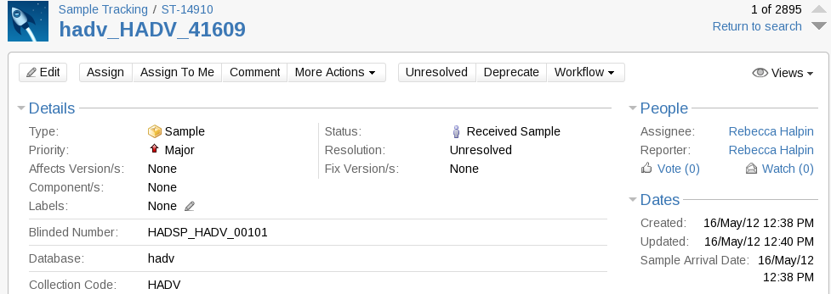
Illustration 5: Issue summary view

Missing Columns
Issue type specific fields are not shown in the Issue Navigator unless that issue type has been explicitly selected. e.g. For the 'Collection Code' to be visible 'Sample' must be among the issue types selected. Explicitly setting the issue type is needed even if the search only matches issues of one issue type.

Restoring the default Column Layout
If changes have been made to the layout a link to 'Restore Defaults' will appear to the right of the 'Add New Column' drop-down and button. This is not an undo button, the default that will be used is the system default and not the previous settings.

Per Filter Column Layout
The above procedure sets and modifies a user's default column settings. A filter specific column layout can be created / edited in two ways:
- The 'Columns' link in the tools / 'Cog' drop-down menu on Manage Filters page (see Illustration 6: Issue Navigator - Manage Filters) opens the Issue Navigator Columns page for that Filter.
- When a filter, that already has a column layout associated with it, is being used on the Issue Navigator page the tools drop-down menu will contain a link to 'Edit filter's Column Order' (see Illustration 3).
- If a filter is being used that doesn't have an associated column order then the tools menu will contain a link to 'Set filter's Column Order' (see Illustration 7: Issue Navigator – Tools drop-down, Filter without Column Order).
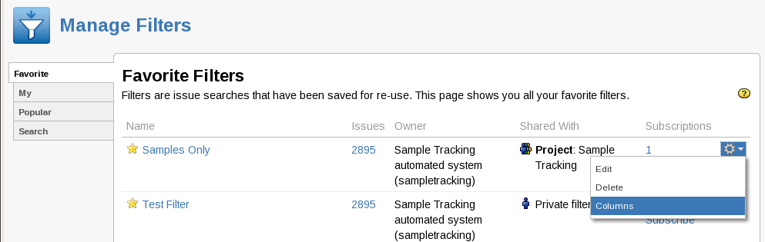
Illustration 6: Issue Navigator - Manage Filters
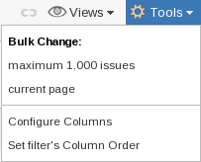
Illustration 7: Issue Navigator – Tools drop-down, Filter without Column Order
The Issue Navigator Columns page used with filters is identical to the Issue Navigator Columns page used with the default column order except that instead of the 'Restore Defaults' link there is a link to 'Remove Filter's Column Order' (see Illustration 8: Add New Column drop-down and button - for stored Filter). This is the only way to remove a filter's customized column order.
Illustration 8: Add New Column drop-down and button - for stored Filter

Custom Fields will only be displayed if all of the issues selected contain that field. See Missing Columns on page 2)

